**First Semester, 2020**

**THT1**

**Total Marks = 100**

**18.30 Wednesday to 18.30 Thursday**

1. Why do we not plot the acf of the autocorrelation structure in the raw data when we are modelling a Non-stationary Time Series but do plot the acf of the Residual Series?

(10 marks)

Because when we plot the acf of the raw data, it might have other patterns like trend, cycle, and seasonality. These patterns together with autocorrelation will appear in the acf plot, which makes it harder to detect autocorrelation. When we plot the Residual Series, if we have modelled all the other patterns (trend, cycle, seasonality) successfully, it will just show autocorrelation (if present). From there, it is easier to see if we can model the autocorrelation successfully by fitting a lagged response.

Model answer：

The plot of the acf is used to assist in determining whether the assumptions of the model are satisfied. The errors must be independently and identically distributed from a normal distribution with 0 mean constant variance: 𝜀௧~𝑖𝑖𝑑𝑁(0, 𝜎ଶ). The plot of the acf of the residuals is used to assess the independence aspect of the assumptions. While there will nearly always be an autocorrelation structure in the raw data, the model’s components (trend and seasonality) will remove some, or on rare occasions all of that autocorrelation pattern. The autocorrelation that remains appears in the Residual Series.

2. When will a lagged response variable added as an additional explanatory variable account for all of the autocorrelation detected in the Residual Series of our initial model?

(5 marks)

When the residual series shows no clustering or oscillations and the plot of acf shows no significant lags (other than lag0, which is always = 1).

A lagged response variable will take care of all of the autocorrelation in the initial model when the plot of the acf shows exponential decay and the plot of the pacf shows only 1 significant lag at k = 1.

3. ***Sketch or Describe*** the plot of the acf for a quarterly Time Series with a strong positive trend and a random component. Assume the variable is a .ts object.

(10 marks)



Answer:

Plot labels (axes & title) (2 marks) 2

Quarterly x-axis by year (3 marks) 3

Exp decay - annual (3 marks) 3

Exp decay - quarters (2 marks) 0

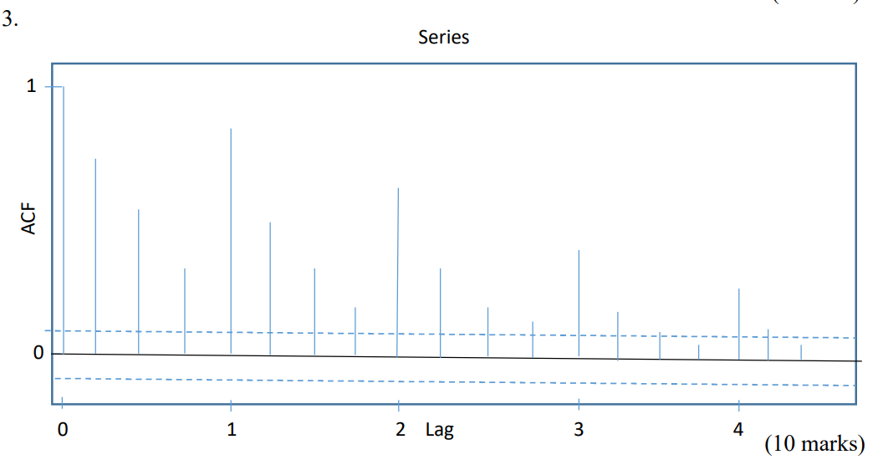

4. If we had a Time Series with 625 observations, what are the values for the 95% confidence bands in a plot of the autocorrelation function of the Residual Series?

(5 marks)

5. We differenced a Non-stationary Time Series once to remove the trend and twice to remove the quarterly seasonal component producing a White Noise Residual Series. Write down the model using backshift notation and express it in the form: *yt* = ……..

(20 marks)

6. Briefly discuss the plot of the Global Nitrous Oxide data on page 1 of the Appendix.

(5 marks)

The plot of monthly Atmospheric N2O appears to have a positive increasing linear trend with reasonably constant seasonal components. Although the seasonality is not so obvious around year 2014. The linear trend seems to be very steady and the global N2O has increased from 316 to 332 ppm, with an increase of approximately 1 ppm per year.

Answer:

Linear trend (1 mark) 1

Break (2 marks) 0

Seasonal peak (1 mark) 1

Seasonal trough (1 mark) 1

The Monthly Global N2O atmospheric concentration shows an increasing reasonably linear trend that appears to have a change in slope around August 2007 (observation 80). There appears to be a seasonal pattern with the seasonal peak around January and the seasonal trough around August.

7. Calculate the predictions for July to October 2019 using the Holt-Winters model on page 2 of the Appendix.

(10 marks)

8. a. Identify the most important feature of the plot of the seasonally adjusted series on page 3 of the Appendix.

(3 marks)

We can see clear positive increasing linear trend with a possible break – change in slope somewhere around 2007. The slope after that became slightly steeper.

Answer:

The plot shows that the trend is increasing and is reasonably linear until around observation 80 (August 2007) when the slope increases, but remains reasonably linear.

b. Using the information on pages 3 and 4 of the Appendix, are the assumptions of the Moving Average Seasonally Adjusted model satisfied? Explain briefly.

(12 marks)

There is still very slight clustering in the Residual Series, but it seems to come from a normal distribution with mean 0 and reasonably constant variance. The plot of acf showed only lag1 is slightly significant. It is very small autocorrelation so we can ignore it. Check residual in the summary, we can see the absolute value of min (-0.1668) is very similar to the max (0.1572), same for 1Q (-0.0402) and 3Q (0.0407), and the median is very close to 0 (0.0009). The residual standard error is very small as well (0.05969). We can be confident that the residual is normally distributed. So the assumptions are satisfied.

Answer:

The plot of the Residual Series shows reasonably constant scatter with a zero mean. The acf of the Residual Series shows 1 significant positive lag (lag 1) which is small enough to ignore (especially given the autocorrelation estimate is 0.9). The 5-number summary of the Residual Series has a median close to 0, similar absolute values for the 1 st and 3rd quartiles and similar absolute values for the minimum and maximum indicating the distribution is very symmetric. Normality appears satisfied. The Residual Series appears to be White Noise - 𝜀௧~𝑖𝑖𝑑𝑁(0, 𝜎 ଶ) as required for the assumptions to be satisfied.

9. Calculate the predictions for August and October 2019 using the Moving Average Seasonally Adjusted model on page 4 of the Appendix. Calculate the RMSEP statistic for the July to October 2019 predictions. (Note: the actual values for July to October 2019 are at the bottom of page 1 of the Appendix and the July and September MA model predictions are given at the bottom of page 4 of the Appendix.)

(15 marks)

10. Which model is the best predicting model for July to October 2019? Why?

(5 marks)

Moving Average Seasonally Adjusted model is better since it has smaller RMSEP ($0.1033747 ppm$) than the Holt-winters exponential smoothing model (0.1197699 $ppm$).